**TRANSFER OF WOUND CARE**

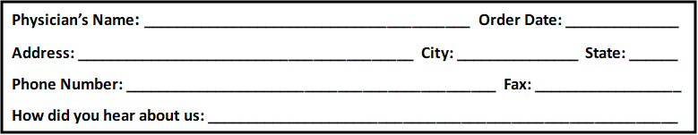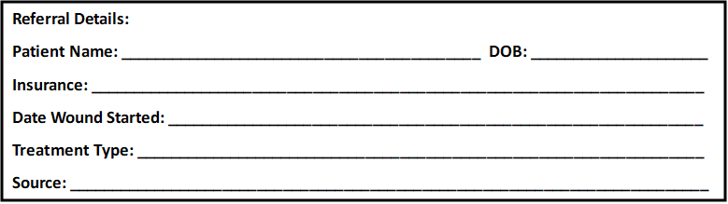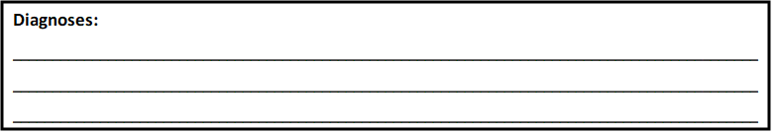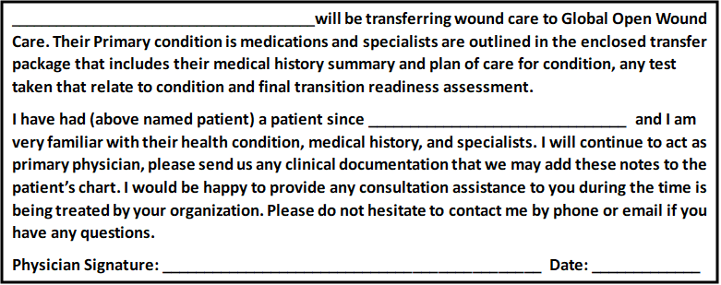 **Please Fax or Email: 469-574-7757**

[**southwestcentralwoundcare@swwound.com**](mailto:southwestcentralwoundcare@swwound.com)

* **Transfer of Care Form**
* **Demographic page with insurance information attached.**
* **All office note pertaining to wound care services plus medical history.**
* **Provide images of the patient’s wounds if applicable.**